Date:31.01.2022

**Third Year B. Tech., Sem VI 2021-22**

**Advanced Database System Lab**

**Assignment submission**

**PRN No: 2019BTECS00064**

**Full name: Kunal Santosh Kadam**

**Batch: T2**

**Assignment: 2**

**Title of assignment: PL/SQL Review And Object Relational Database**

1. **PL/SQL Review:**
2. Create a table called test_table with 2 columns RecordNumber (type : Number(3)) and CurrentDate (type : Date)). Write PL/SQL block which will insert 50 records into test_table. Insert the current date value into the table.

Ans

**Create table test_table:**

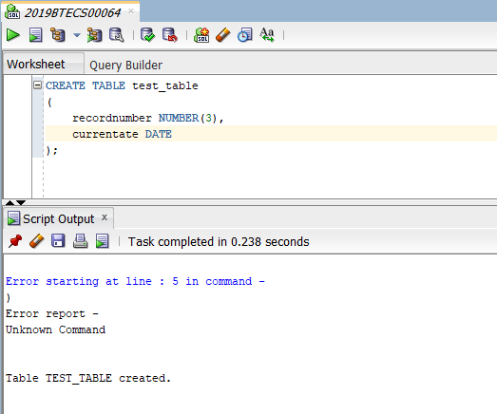

**PL/SQL statement to add 50 entries:**

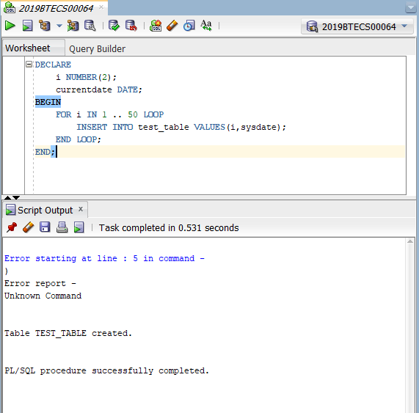

**Table Values:**

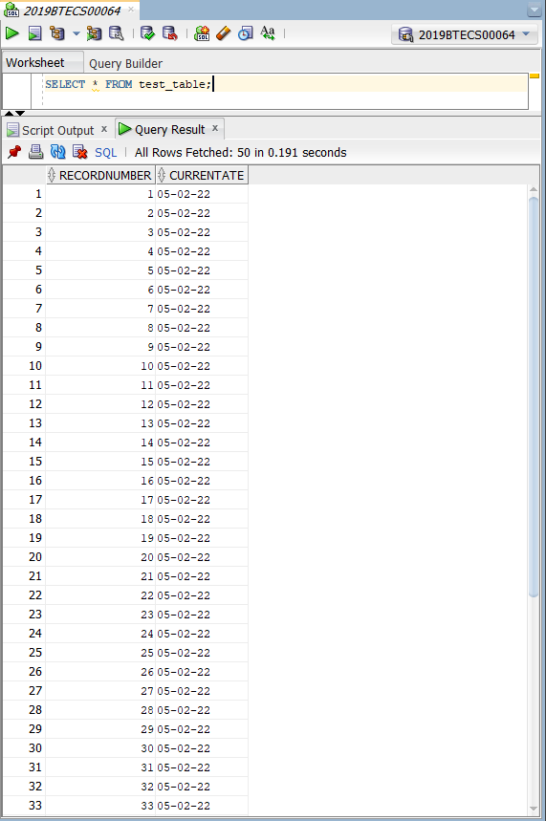

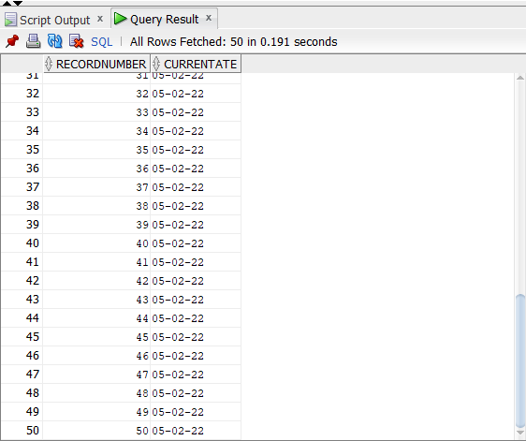

1. Create a products table products(ProductID number(4), category char(3),detail varchar2(30),price number(10,2),stock number(5)). Insert the sample data.

Write PL/SQL procedure with two arguments X & Y which will increase price by X% for all products in category Y. X and Y will be given by user.

Ans

**Create Products table:**

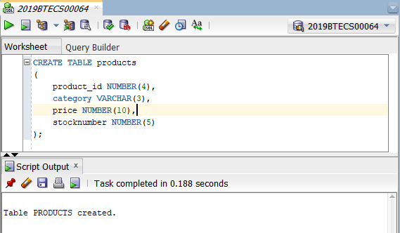

**Table Data:**

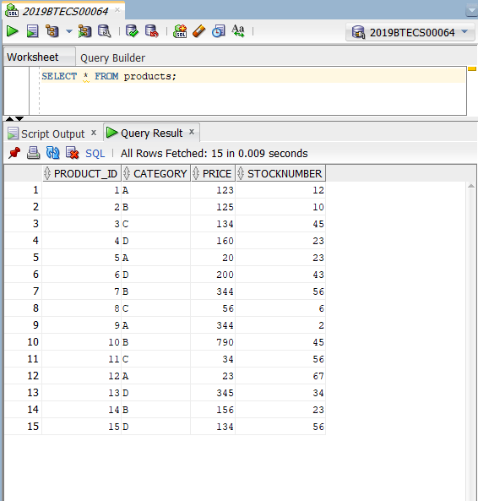

**SQL Procedure to update price:**

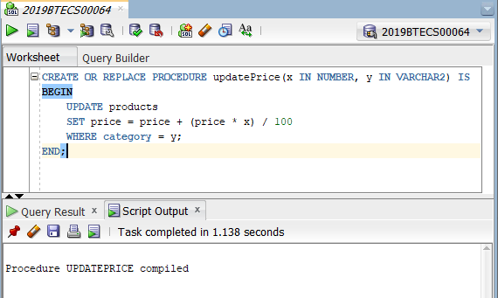

**Invoking updatePrice:**

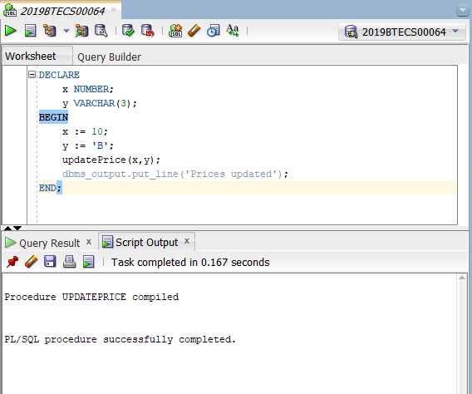

**Table after updating prices:**

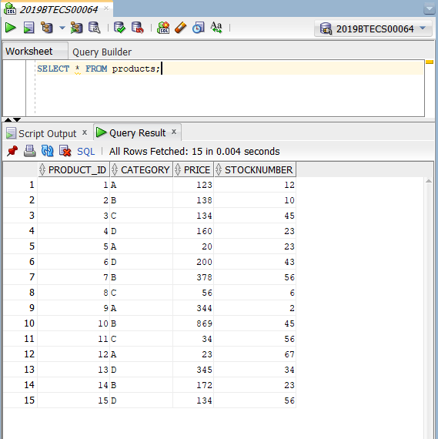

1. **Object Relational Databases:**
2. Create Object Table containing field “name” of size 50 characters and member function “countNoOfWords” which returns the no. of words in “name” field.

Demonstrate the working by entering different data.

Ans:

**Create the type “word”:**

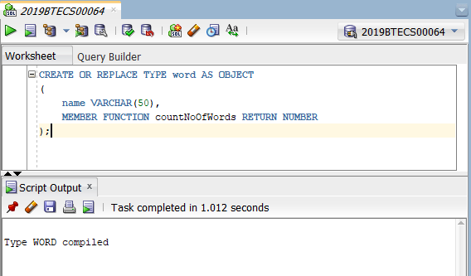

**Create the body of the type “word”:**

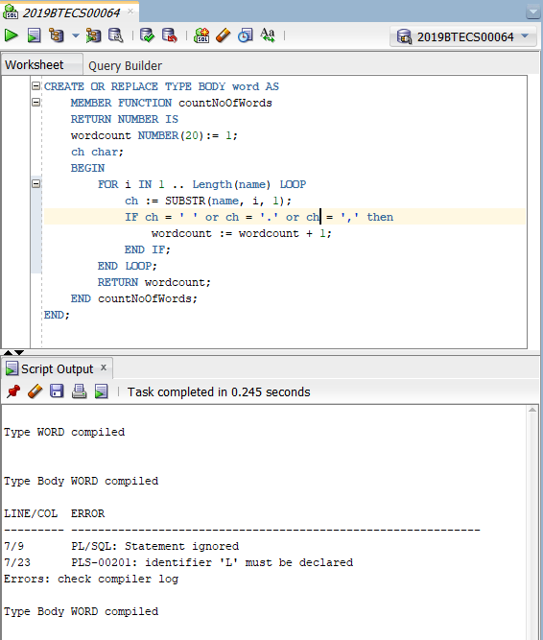

**Create table of word type:**

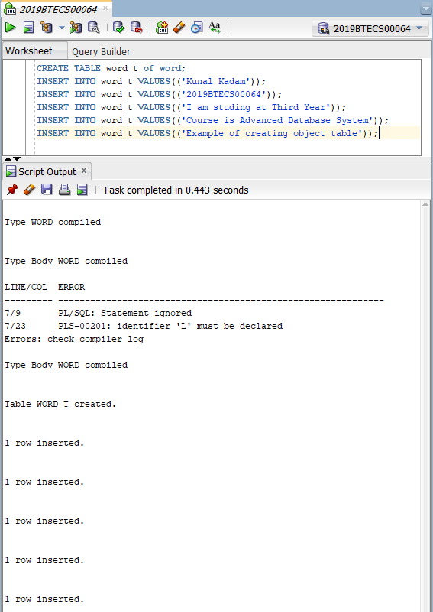

**Query to get count of words:**

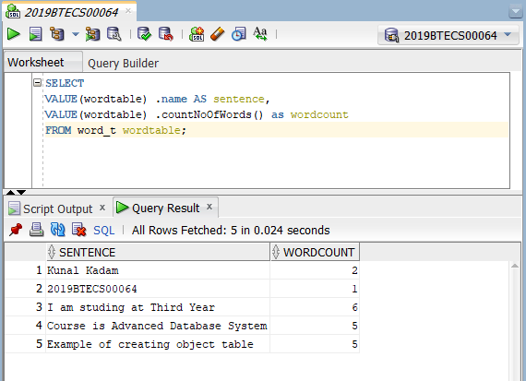

1. Create an address type with the following attributes: address, city, state & pin code. Include the following methods
2. To extract the addresses based on given keyword.
3. To return the no. of words in each given field (method should accept the name of attribute/field)

Ans

**Create Type “address”:**

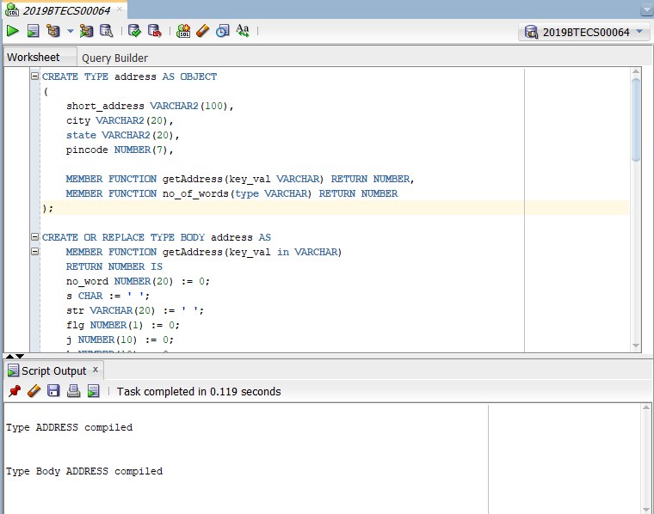

**Create body for the “address”:**

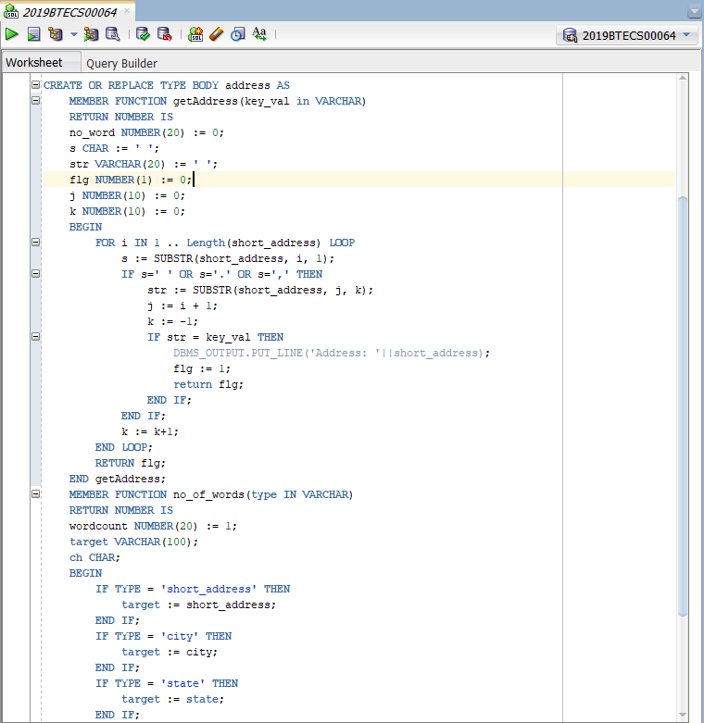

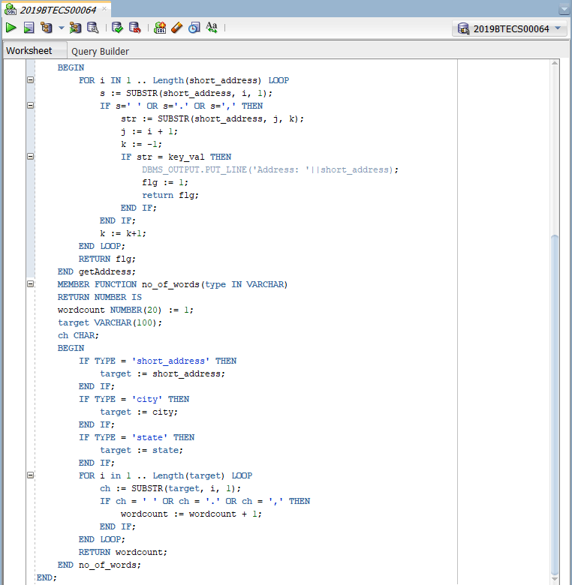

**Table Entries:**

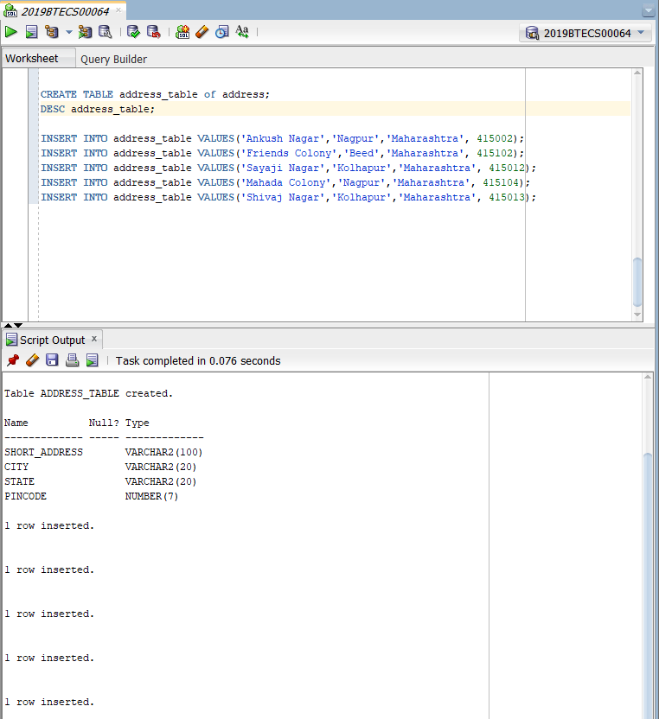

**Word count based on attribute name:**

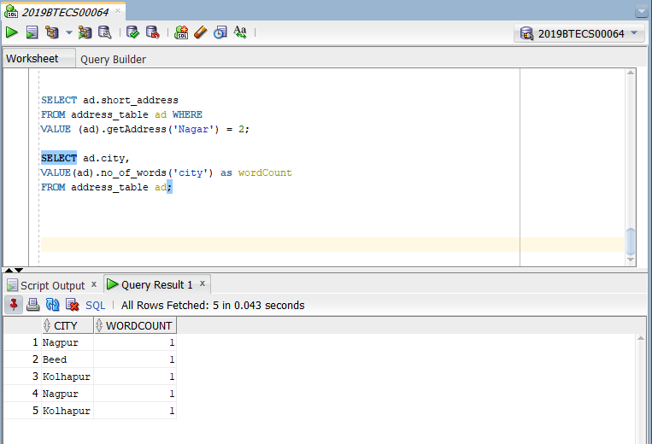

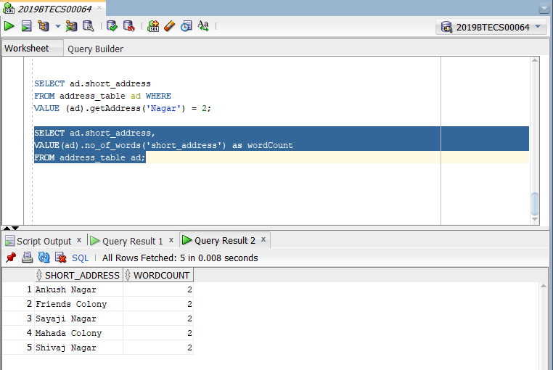

1. Create a user defined data type course_Type with 2 attributes course_id, description:
2. Create an object table based on the type created.
3. Insert rows into the table.

Demonstrate the working with different data sets

Ans

**Course Type:**

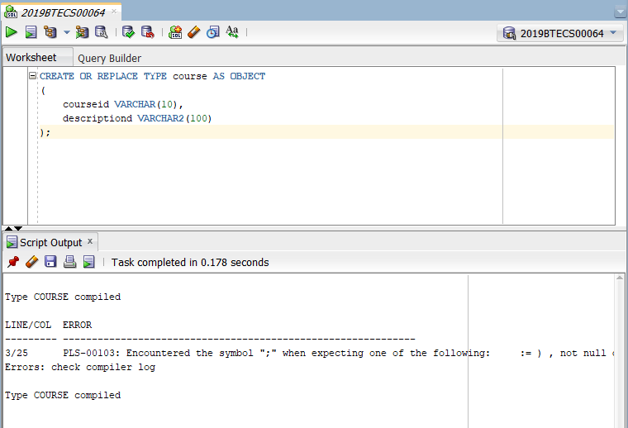

**Creating Table of Type Course:**

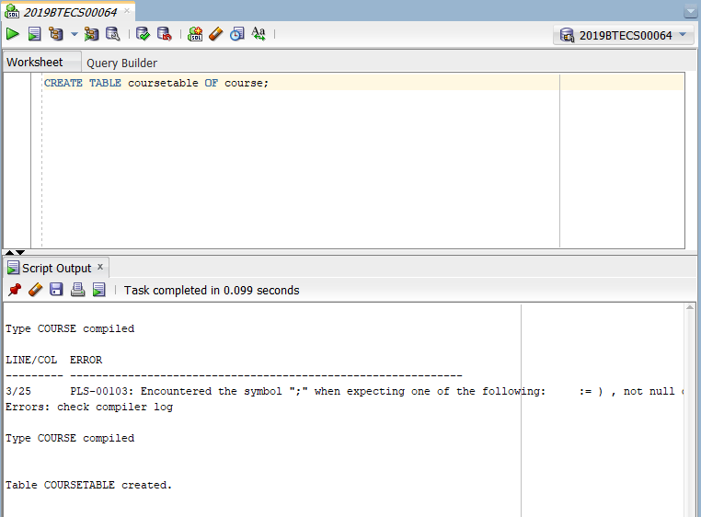

**Insert Values into Table:**

